 | 8.50 – 9.00 | 9.00 – 9:30 | 9.30  – 10.30 | 10.30 – 10.45 | 10.45 – 11.45 | 11.45 – 12.00 | 12.00 – 13.00 | 13.00 – 13.20 | 13:30-13:45 | 13.12 – 14.10 | 14:10 –  14: 30 | 14.30 - 15.15 | 15:15-  15:30
Monday | Morning starter | 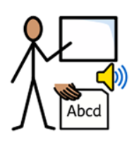  Phonics | 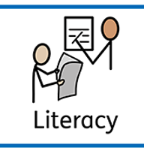  English | 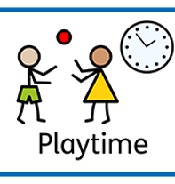  Break | 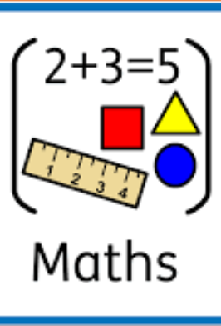  Maths | Phonics Recall | 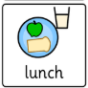Lunch | PHSE | 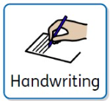Handwriting | 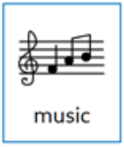  Music | Break | 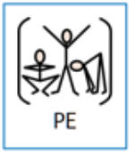PE | 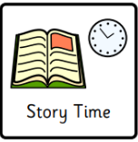Class read
Tuesday | Morning starter | Phonics | English | Break | Maths | Phonics Recall | Lunch | 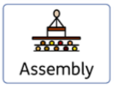Assembly  Y1 Readers | Handwriting |   Geography | Break |   Science | Class read
Wednesday | Morning starter | Phonics | English | Break | Maths | Phonics Recall | Lunch | Assembly  Y1 Readers | Handwriting |   Guided Reading | Break | 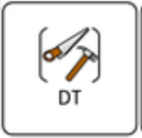  Art | Class read
Thursday | Morning starter | Phonics | English | Break | Maths | Phonics Recall | Lunch | Singing  Assembly  Y1 Readers | Handwriting | 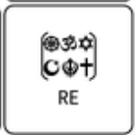  RE | Break | PE | Class read
Friday | Morning starter | Phonics | English | Break | Maths | Phonics Recall | Lunch | Guided Reading | Handwriting | 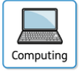Computing | Break | PSHE | 15.00 – 15.30  Celebration assembly

