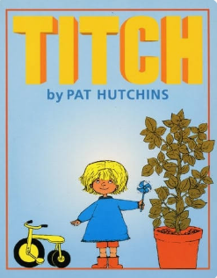
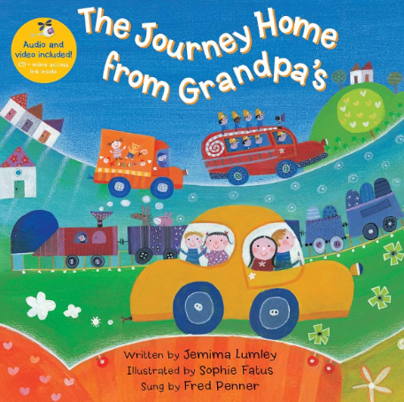
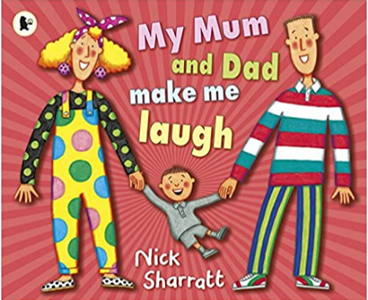
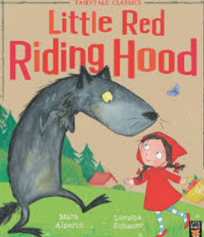
At home you can:
-Talk to your child about family and friends
-Look at photographs about your family.
-Share your favourite stories.
-Encourage daily independence such as dressing and toileting.

Books we will use to support our learning this half term:

By the end of this half term, we will be able to talk about:
- Simple class rules and routines needed to keep everyone happy and safe.
- Who lives with us – naming family members.
- Feelings and emotions.
- How we are unique and similar.
- Our likes and dislikes.

Key Vocabulary:
Family, Mum/Mummy, Dad/Daddy, Grandma, Grandad, aunt, uncle, cousin, friends, special, unique, feelings, happy, excited, sad, sharing, caring.
I like…
I don’t like...
I feel happy when I…

Meet the Oxford Reading Tree Characters.
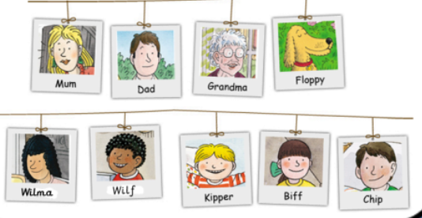
This half term we will be learning about ourselves, our families, our classmates and ‘All About Me!’.
What makes us unique? Autumn 1

