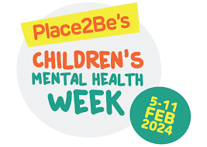

Monday 5th February- Friday 9th February
Theme: My Voice Matters

From Monday 5th February-Friday 9th February, School Council have been busy planning activities linked to this year’s theme, which is “My Voice Matters”. This is about finding different ways to share feelings, thoughts, and ideas in creative ways. This could be through dance, music, art, writing, poetry, or other activity that makes you feel good.
The children spent the week creating posters, writing letters, practicing mindfulness, and discussing the things that make them feel happy and how they like to express their unique characters. We celebrated the week with daily assemblies.
- Whole school assembly Monday 5th February with a special message from PCSO Rebecca (schools wellbeing champion)
- Tuesday 6th February Internet safety assembly
- Wednesday 7th February School Council assembly, children read out thank you letters & give a shout out to someone who has helped them.
- Thursday 8th February singing assembly
- Friday 9th February celebration assembly

Children across the school completed: My proud moments worksheet, during circle time & PSHE.

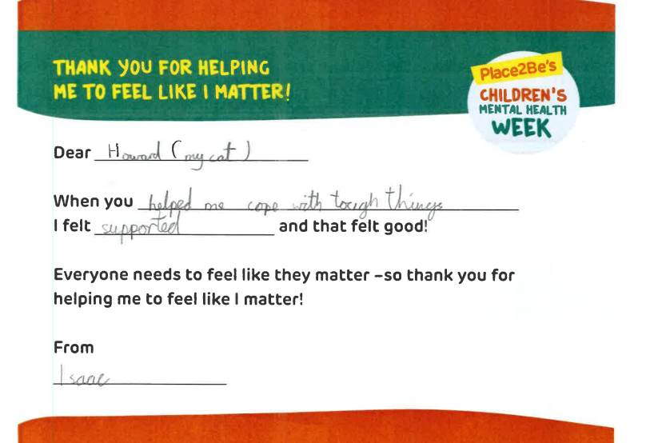
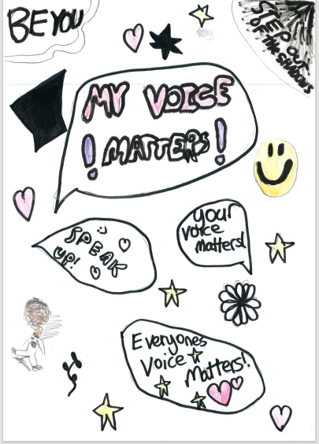

Huge well done to the School Council and everyone for taking part!

