School Council Eco Club Meeting
Wednesday 29th November 2023.

School Council met with Sue from Energy Heroes to discuss & work with Energy Heroes to help Spring Bank Primary School to become more Eco Friendly.
The children looked at all the different ways Spring Bank can save energy & make changes to help our school, environment, and the climate.
Here are some of the different areas the children explored & came up with the following aims to work on
- Compost bins on the pitch & the roof
- Gardening Club
- Litter picking
- Switching off lights around school which are not in use.
- Reduce packaging for school dinners.
- Currently school is recycling unwanted/used batteries, look at recycling crisp packets & felt tip pens.
- Cooking Club: Use the food the children grow at gardening club.
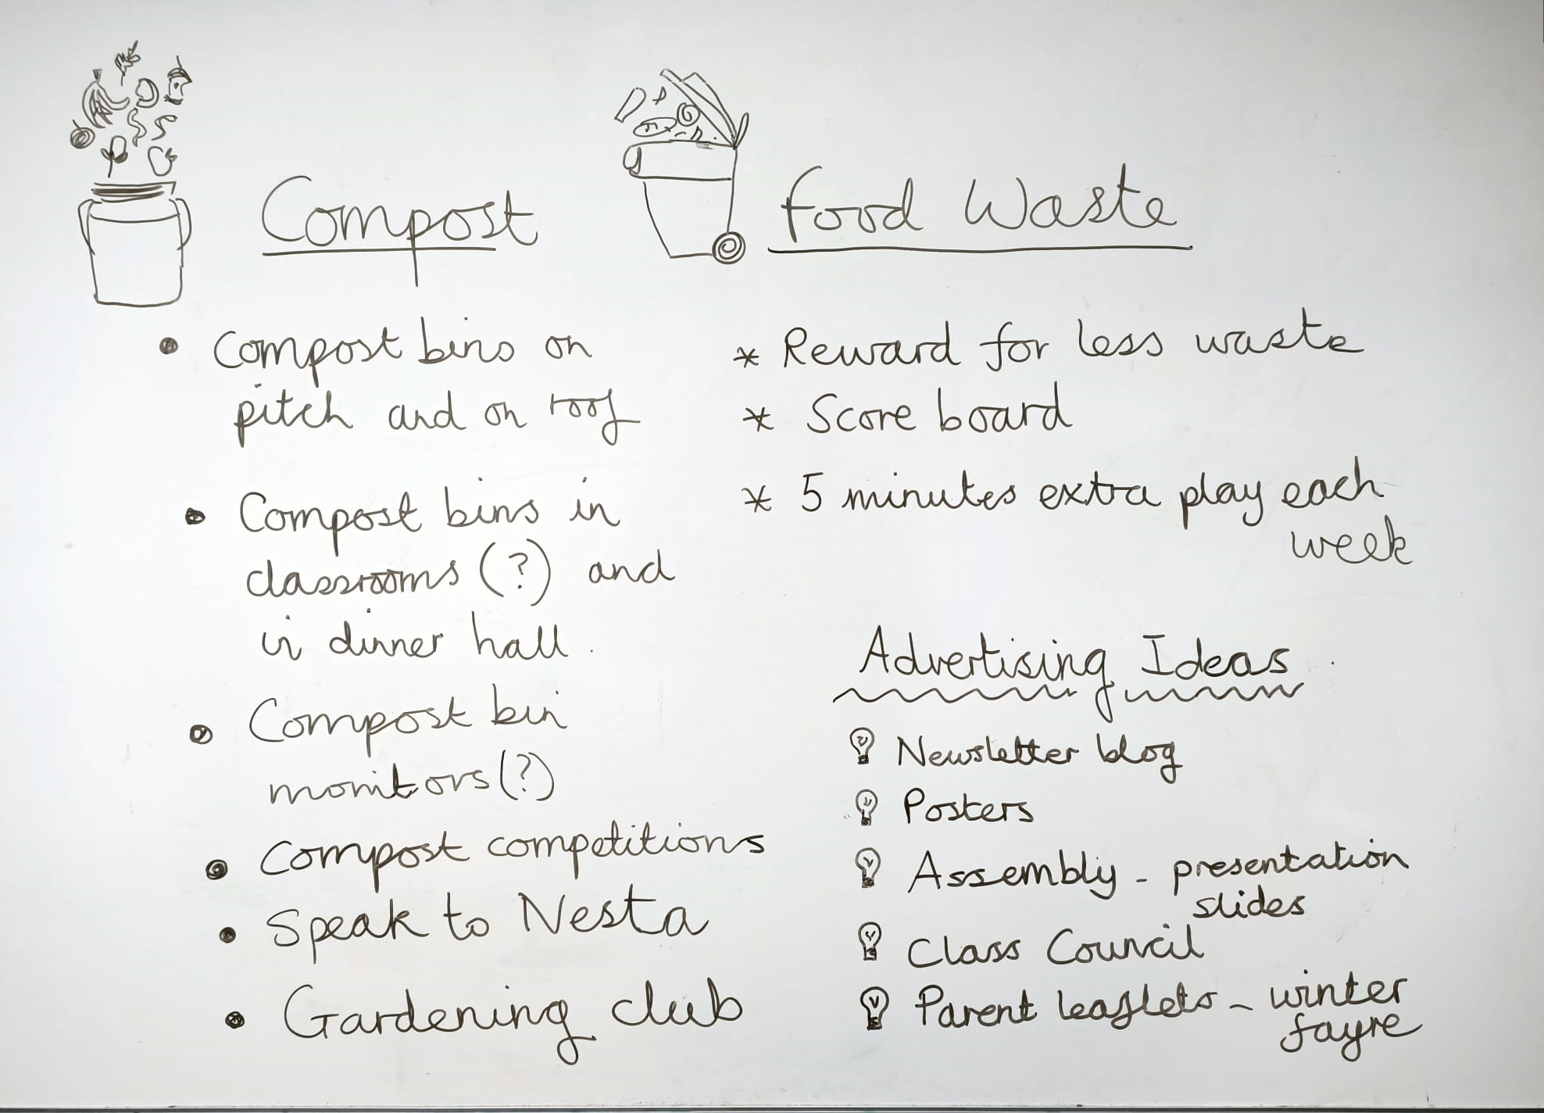
Tuesday 5th December Miss Ditta & School Council held an Eco-Friendly Assembly to share aims & plans to help our school.

