Welcome to

Spring Bank Primary School

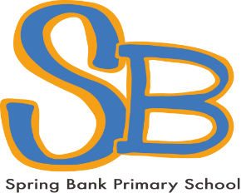

Successful learners
Confident individuals
Responsible citizens

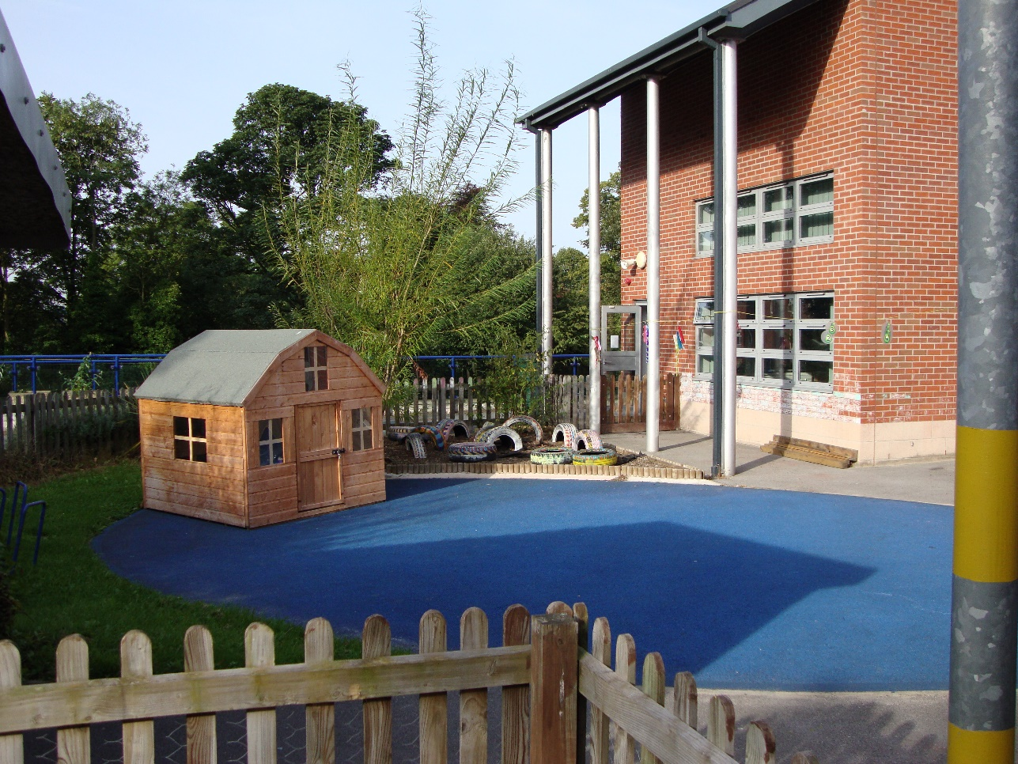

Where to find us

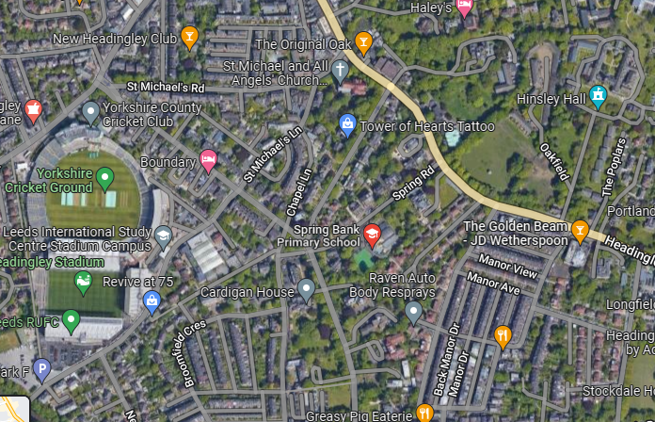

Situated close to Yorkshire Cricket Ground and the bus routes along Otley Road and Cardigan Road, Spring Bank Primary lies on a quiet street, with beautiful grounds consisting of mature trees and shrubs.

Spring Bank Primary School
Spring Road,
Headingley,
Leeds
LS6 1AD
0113 2043120

hello@springbankprimary.org

Welcome from the Headteacher

Welcome to Spring Bank Primary School. We are really pleased that you are thinking about sending your child to us. When choosing the right school for your child there is always lots to think about and you can only get a feel for a school by visiting it and seeing the ethos of a school for yourself. We welcome visitors to our school at any time and offer regular open mornings and evenings. Please look out for these on our website.

Spring Bank Primary is a friendly, inclusive and values-driven school in a culturally rich and diverse area of Leeds. We are passionate about building a school community in which every child is valued and is enabled to reach their full potential. Parents choose our school for its supportive and caring environment with a distinctive community ethos. Children are happy at our school and grow steadily in confidence during their time with us. They make very good progress throughout school, achieving highly when they leave us at the end of Year 6.

At Spring Bank Primary, we are proud of our broad and balanced curriculum with a focus on the local community, our commitment to outdoor education and our development of responsible global citizens. Sustainability is important to us and we encourage children to reflect, make positive choices and think about the world they want to grow up in.
We ensure that there are regular visits and visitors into school to enhance children’s learning across the different subjects. We have beautiful grounds behind the school and have a Forest Schools teacher to teach groups of children throughout the year. We also have our own school allotment which is looked after by our children in Year 4 and our Year 6 children go on a week’s residential to Ingleborough Hall each year.

Please do arrange to come and meet us so that we can answer any questions you may have.

Miss Amy Houldsworth (Acting Head of School)
Mr Jonathan Parker (Executive Headteacher)

Our Vision and Aims:
We learn and explore together; we create and achieve together and we celebrate together.

Our school is a happy, safe, and special place full of learning, fun and friendship. Through our Spring Bank curriculum, we aim to develop a love of learning inspired by quality teaching that builds on the strengths and skills of our children, valuing them each as individuals.

We embrace imagination and creativity and aim for all children to achieve their potential, developing future passions and talents. Our broad and balanced curriculum provides practical and inspirational ways of teaching which in turn encourages and fosters enthusiasm, perseverance and resilience. We aim for all our children to work collaboratively together and to communicate effectively. By the time our children leave Spring Bank they will have developed the skills to become lifelong learners and to have a love of learning.

Children, our partnership with their families, and our community, are at the heart of everything our school does. We promote the importance of respect and community and children at our school recognise their responsibilities towards each other, our culturally diverse local community and the wider world. This is underpinned by our School Values

Throughout their years at Spring Bank our children become:
- Successful learners who enjoy learning, make progress and achieve their full potential.
- Confident individuals who are able to live safe, healthy and fulfilling lives.
- Responsible citizens who make a positive contribution to society.

Inclusion
Spring Bank Primary is a school known for its fully inclusive ethos, with a focus on the welfare of the individual. We ensure that every child, no matter what their individual needs or barriers to learning, has equal access to learning and the same opportunities to achieve. We do this by creating a learning environment that works for all pupils, whether they have a disability, speak English as an additional language, are a member of a minority community, come from a low-income family – or find it harder to learn and achieve for other reasons. The school is fully committed to tackling discrimination, actively promoting race equality and fostering positive attitudes and commitment to an education for equality.

Race equality
Spring Bank Primary School is a school with an ethnically diverse population. We are committed to the promotion of equality of opportunity for all, including people from different racial, ethnic, cultural and religious backgrounds. We consider that all manifestations of racism are wholly unacceptable and act positively to eliminate racial discrimination where it occurs. We take prompt, effective and systematic action to deal with all racist incidents and to identify and address racial, ethnic, cultural and religious inequalities. We are also committed to promoting good relations between people of different racial, ethnic, cultural and religious groups.

Our children participate in a curriculum that takes full account of the richness and variety of the world’s racial, ethnic, cultural and religious groups and develops understanding of some of the main causes of global inequality, disadvantage and poverty. Our children learn how to recognise and challenge racism, racial discrimination and stereotyping and in doing so develop the knowledge and understanding, skills and attitudes necessary for life in Britain’s multi-ethnic society and as global citizens in an increasingly interdependent world.

Special Educational Needs and Disability
All pupils at Spring Bank Primary School receive Quality First Teaching. This means that a range of teaching and learning styles are used and appropriate learning objectives are set for all pupils. Teachers adapt the delivery of the curriculum to ensure that they meet the needs of all pupils. At Spring Bank, the progress and attainment of all our pupils is reviewed termly by the Senior Leadership Team. Based upon this, class teachers then arrange specific provision to support those pupils not making expected progress. This could include small intervention group work, booster groups, small group tuition or catch up programmes. Some pupils may need additional pastoral support with social / emotional issues and provision for these pupils is also available from our Learning Mentor. Teachers keep parents informed about their child’s progress during the year and, in consultation with parents, may agree to raise a concern if the pupil is in danger of falling behind. The SENCo and class teacher will identify needs and plan appropriately which may involve adapting the delivery of the curriculum or including the pupil in intervention groups.

Pupils with Special Educational Needs and Disabilities
If a pupil continues to have difficulties after receiving specific provision in intervention groups and continues not to make the expected progress, they may be considered to have Special Educational Needs or Disabilities (SEND) and will be placed on the SEND register. A child or young person with SEND will have a significantly greater difficulty in learning than the majority of others of the same age or will have a disability which affects how they can access the curriculum. They will have an SEN support plan and some children with more complex needs may undergo an Education Health and Care Assessment. This can be requested by parents, school or health and will be managed by the Local Authority. This may lead to an Education Health and Care Plan. A very small percentage of pupils will require this level of support.

Medicines
From time to time, children need to receive prescribed medication in school. Parents/carers may come in to administer this. If the medication is to be administered by the school, parents/carers must complete an authorisation form available from the school office. Medicines need to be clearly labelled with the name of the medication, the child’s name, the dosage and the timing of dosage. Medicines brought into school must be handed in to the school office. Many children in school are asthmatic and need inhalers. Children who use them need a named inhaler for school which are stored in the classroom in medicine bags. Each class also has an emergency inhaler for when children have forgotten to bring their own to school. Again, inhalers can only be kept in school when parents/carers have filled in the appropriate form from the school office. First Aid will be given to any child who needs it. In the event of any serious incident parents/carers will be informed immediately. Please inform us (by telephone or in person) if your child is to attend a doctor/dentist/hospital appointment.

Admission to School
Children are normally admitted to the Reception class in September if their 5th birthday is in the school year between the 1st September and the 31st August of the following year. Legally, children must be in full-time education from the start of the term following their 5th birthday. For children due to start Reception, Leeds City Council sends application forms directly to parents in the October preceding the school year in which they are 5. Parents record their preferences and places are allocated in accordance with the Leeds City Council’s admissions policy. In the spring term parents are notified of the school to which their child has been allocated. Parents have the right to appeal to Pupil Admissions if they are unhappy with the place allocated.

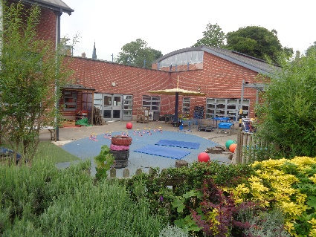
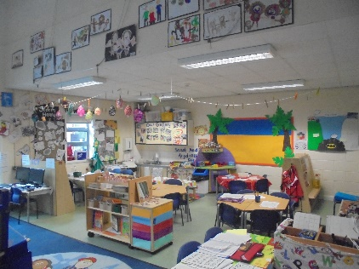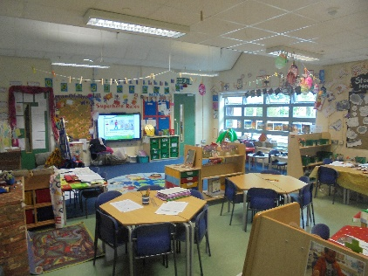

Working with Parents

We believe that the success of our school depends on children, teachers and parents/carers working closely together. We like to keep our parents/carers regularly informed of all aspects of school life. The school is committed to regularly reviewing, and improving still further, its communication with parents/carers. All staff are keen to listen and help, and any concerns will be addressed promptly. In the first instance please have a word with your child’s class teacher. In accordance with DFES guidelines the school has an official complaints policy, which is available from the school website.

Communication and Information

The school uses an app called Parentmail to communicate with parents through email and texts. Information about events in school will be sent out regularly in the weekly School Newsletter and a copy is also uploaded onto the website so that it can be translated into other languages through Google Translate. The school also uses an App called Class Dojo to communicate with parents and children. Homework and photos are uploaded by class teachers and there is also a message facility to enable parents to contact class teachers. School policies can be found on the school website, as can a range of other information including minutes of PTA meetings. Information sessions, such as Phonics Evenings, the Year 6 Residential and Sex and Relationship Education briefing meetings, will be held as required.

The school places an emphasis on good home/school communication and we encourage parents to share any concerns or information informally at any time they arise. Class teachers are available at the door for quick messages in the morning. For a longer discussion about your child please arrange an appointment with your class teacher. We also have two Parents’ Meetings during the year to share information with you about how your child is doing in school. These can be booked through the Parentmail app.

Assemblies
Assemblies are held daily in school. On Friday we have a Good Work assembly, where children are chosen to receive certificates from their class teachers. Throughout the year we invite parents from each year group to attend Friday Good Work Assembly to watch children from their class receiving certificates. Following the assembly, we invite you to stay and attend a workshop with your child linked to the National Curriculum.

Our School Day
The school day starts at 9am and finishes at 3.30pm (3:25pm for Reception). In Reception and Key Stage 1, doors open from 8:55am to give children time to settle into the school day. Registration is from 9:00-9:10am.

Morning Playtime
Morning playtime is from 10:40-10:55am. Children are welcome to bring a piece of fruit to eat at playtimes. Playtime for Key Stage 1 is on our rooftop playground, where toys are provided for the children and our older children organise games for the younger children. Playtime for Key Stage 2 is on the school pitch, where we have a climbing wall and football nets.

Lunch
Children in Reception have their lunch at 11.55am; all other children have lunch at 12.00 noon. Lunchtimes for all end at 1.00pm.

Afternoon playtimes
All children in school have a short ‘brain break’ in the afternoon of 10 minutes. They play in the area outside their classrooms or on the school playgrounds.
The school is very lucky to have a beautiful area of trees and mature shrubs behind the school. When the weather is fine, we play ‘on the grass’ as much as possible.

Drop-off and collection
At the beginning and end of the school day, parents drop off and wait for their children outside their classrooms. If normal arrangements have to be altered (e.g. you are delayed or another person is collecting your child), please let us know. This avoids any confusion or upset.

Getting to school
To get to and from school, walking is definitely the best option! Alternatively, we have bike-racks and scooter racks in the car park area. If you do need to travel by car, please park wisely on Spring Road as it can become very congested.

School Meals
School provides parents/carers with a copy of the school dinner menu at the beginning of each term. The menu is also available on the website www.springbankprimary.org We encourage parents/carers to help their children make choices by talking through the menu with them.

Universal Free School Meals
All children in Reception, Year 1 and Year 2 are entitled to free school meals. Our meals are designed and provided by Mitie and provide nutritionally balanced, delicious and healthy choices for your child. All medical and religious diets can be catered for. At Spring Bank we serve 4 meal choices each day, which includes a meat/fish dish, vegetarian dish, a jacket potato option and a sandwich option. Each meal includes a main course, vegetables and salad, pudding of the day, crackers or fruit or yoghurt and chilled water. We do not serve pork in school and all our meat is halal.
Cost of school meals:
Years 3 – 4 £2.65 per day £13.25 per week
Years 5 – 6 £2.75 per day £13.75 per week
Payment for school meals should be made in advance every Monday morning, or at the beginning of each half term on Parentmail. A week’s notice should be given for changing from school dinners to packed lunches or from packed lunches to school dinners.
Children may bring a packed lunch and a drink in a clearly named lunch box. Do not send fizzy drinks, cans or glass bottles to school. When sending your child to school with a packed lunch, please can you be mindful of national guidelines. It is recommended that packed lunches should include:
• at least one portion of fruit and one portion of vegetables every day.
• meat, fish or other source of non-dairy protein (e.g. lentils, kidney beans, chickpeas, hummus, and falafel) every day
• oily fish, such as salmon, at least once every three weeks.
• a starchy food such as any type of bread, pasta, rice, couscous, noodles, potatoes or other type of cereals every day.
• dairy food such as milk, cheese, yoghurt, fromage frais or custard everyday
• only water, still or sparkling, fruit juice, semi-skimmed or skimmed milk, yoghurt or milk drinks and smoothies. (School provides water for drinking at lunchtime)
Please do not include any nuts or nut butters such as peanut butter in your child’s lunchbox as we have children in school with nut allergies. Packed lunches should also not include crisps or confectionary such as chocolate bars, chocolate coated biscuits and sweets, or sugary cake.
Milk
Parents/carers can order milk for break times at a cost of £15.00 per year. This is paid for through Parentmail.
School Uniform
Following consultation with our parents’ Spring Bank has an optional school uniform. The school uniform consists of:

Shirts - Collared or Polo- White, Grey or Pale Blue
Trousers - Grey or Black
Skirts/Dresses - Grey or Black - Standard School Dress in summer
Jumpers etc. - Navy Blue
Sweatshirts - Navy Blue - With/out the school logo
Shoes - Flat and Practical

The school sells polo shirts with the school logo on for £7.50 in the school office.

The following PE kit is essential and should be in school all week: Sports Trainers (no pumps) black shorts/ leggings and white T-shirt. Children who are not participating in PE must bring a letter from parents stating the medical reasons for absence.

It is important that all children’s clothes and footwear are clearly named so that they can be returned to their owners if lost. A box containing lost property is kept at the front of the school next to the office. At the end of each term, unclaimed items are sent to the charity shop.

All jewellery, with the exception of stud earrings should remain at home (no bracelets, necklaces, hoop or dangly earrings), and whilst watches may be worn they are the responsibility of the children at all times. Smart watches are not allowed.

Volunteering in School
Parents / carers are always welcome in school to help and support staff and pupils. If you have some time to spare and want to help in school, please let us know what you can offer by filling in a volunteer application form, which can be collected from the school office or downloaded from the website. Parents / carers can support in a wide variety of ways such as helping with practical activities e.g. gardening, reading with children, accompanying school visits, assisting with school clubs, talking to the children about specialist topics, sharing an aspect of your community or culture with others in school and helping school make links with local community groups and businesses to enhance the curriculum.

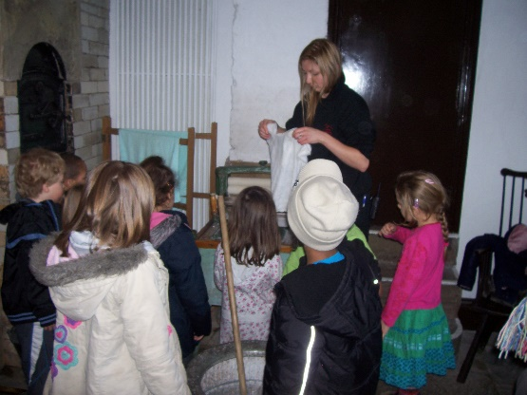
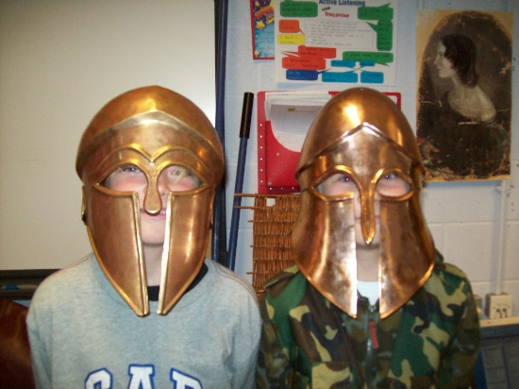

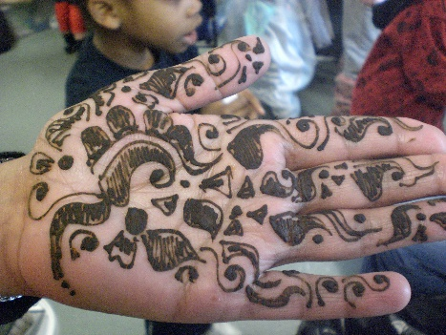
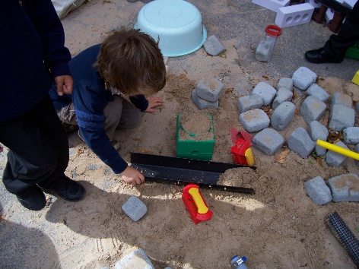

The School Curriculum

Our school follows the National Curriculum for primary schools in England.
At Spring Bank Primary school, there are three phases in total:
- Early Years: ages 4-5 (Reception); the National Curriculum does not cover this phase
- Key Stage 1: ages 5-7 (Years 1-2)
- Key Stage 2: ages 7-11 (Years 3-6)
For Key Stages 1 and 2, there are three core subjects:
- English (spoken language, reading, writing, including grammar and punctuation)
- Mathematics (including number and place value, calculations, fractions, measurements, geometry)
- Science (including ‘working scientifically’)
In addition, there are foundation subjects; for Key Stages 1 and 2, these are:
- art and design
- computing
- design and technology (DT)
- geography
- history
- music
- physical education (PE)
A language is also a foundation subject in Key Stage 2. Religious Education and Relationship and Health Education must also be taught in both key stages.
Information and Communication Technology
ICT plays an important part in our children’s education as we prepare children for careers which do not yet exist. We are constantly evaluating our use of technology in school. We have a networked suite, a class set of Ipads and laptops in each classroom. Each class has its own interactive whiteboard and there is an additional whiteboard in the school hall.

Relationships and Health Education
Relationships and Sex Education (RSE) forms part of our personal, social, health education (PSHE) curriculum. In primary school, it’s important to be clear that the very large majority of RSE is about relationships. The learning is ongoing, and often incidental, learning about relationships with family, friends and others around us. learning the value of family life, safe, stable and loving relationships (including marriage and civil partnerships); and learning the value of respect, love and care. Our RSE curriculum teaches children how to learn to manage emotions and relationships confidently and sensitively; learn to make choices based on an understanding of difference and with an absence of prejudice and learn about physical development at appropriate stages.

Religious Education
We follow the Leeds Agreed Syllabus for RE and aim through religious education to help our children understand aspects of the main religions which exist and to appreciate the importance of belief and non-belief on people’s lives. We aim for our children to visit different places of worship throughout their time in school to appreciate the diverse world in which they live.

Early Years
Children in Reception follow the curriculum for the Foundation Stage, the period of education from 3 to 5 years old, and work towards the Early Learning Goals in the following 7 Areas of Learning: Communication and Language, Physical Development, Personal, Social and Emotional Development, Literacy, Mathematics, Understanding of the World and Expressive Arts and Design. During the Foundation Stage these areas of learning will be introduced through structured and focused play in attractive indoor and outdoor environments.

After School Clubs
At Spring Bank Primary we offer a full range of extracurricular clubs. The majority of our clubs and activities are free, however some clubs carry a small charge to cover the cost of teaching materials. At present, we offer extra clubs in gymnastics, football, cricket, netball, cross country (running), music, choir, dance, chess and history. There are also opportunities for children to take part in sports tournaments throughout the year including the St Bart’s Cup and the Leeds Cross Country League.

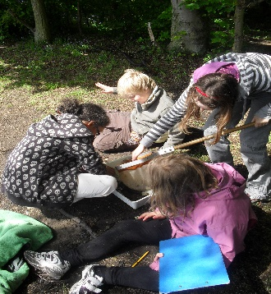

.

Out of School Club
Spring Bank Out of School Club is run directly by the school and offers first class childcare. The club is open Monday to Friday during term time.

Breakfast Club runs from 8am – fee is £5.00 per day
After School club runs until 6pm – fee is £10.50 per day

Booking can be made by emailing oosc@springbankprimary.org and by filling in a form in the office.

Behaviour
At Spring Bank, we believe in a positive approach to behaviour and discipline, where children are given the opportunity to be involved in many of the rules and routines of the school, we also expect the children to have a high level of self-discipline. Our school rules are clearly displayed around the school. Pupils are rewarded for following our rules by collecting ‘dojo points’ and prizes are awarded for collecting a certain number of points.

If a child’s behaviour gives cause for concern, then children work with a member of staff as part of our restorative approach. For incidents of a serious nature, parents will be informed and invited into school to discuss the situation on the day of the incident.

Pupil Voice
At Spring Bank we value the contributions and views of our children. We have a school council made up of two elected class representatives from Y1-Y6 classes. These children discuss issues and ideas with the own classes and bring these forwards to our school council. We also have an eco-council who work with school leaders on issues regarding sustainability. Our councillors and ambassadors also meet with our school governors.

Attendance
We strongly encourage good attendance and punctuality which has a great impact upon children’s outcomes in life. We do not authorise term time holidays. If your child is to be absent from school for a reason other than illness, please complete an exceptional leave form at least one week prior to the absence.

Music
Music is a particular strength of the school. We have talented musicians at Spring Bank and our End-of- Year Performance given by Year 6 pupils is always a highlight to end the school year. All the children in Reception perform a traditional nativity play at Christmas and the pupils in Key stage 1 and Key Stage 2 put on their own concert for parents. All children in Year 5 learn the ukulele and perform to parents at the end of their sessions. Children in Key Stage Two also have the opportunity to take part in brass, guitar and woodwind lessons provided on the school premises by the Peripatetic Music Service. The service is subsidised by the authority and parents are charged at the lowest possible rate with bursaries available for children who are entitled to free school meals.

Community Links
Our school is a community school and we greatly value the links we have made with many local and national organisations. As well as teaching links with Leeds Beckett University and the University of Leeds we support a wide variety of charities. Jeans for Genes, Muscular Dystrophy, Oxfam and Marie Curie have all been supported by our school community in the past. We have strong links with Headingley Cricket and Rugby Clubs, Meanwood Valley Rangers, Ash Road Allotment and the local universities.

Spring Bank Parent – Teacher Association
We have a very supportive PTA, who annually provides extra funding for the school, which is gratefully received. Don’t miss our annual Christmas and Summer Fairs! As soon as your child enters the school you automatically become a member of the PTA, and we hope that you are able to support it in whatever way you can.

Meetings are held each term and all are welcome to attend. Please see our PTA notice board for details and the Spring Bank PTA Facebook page.

