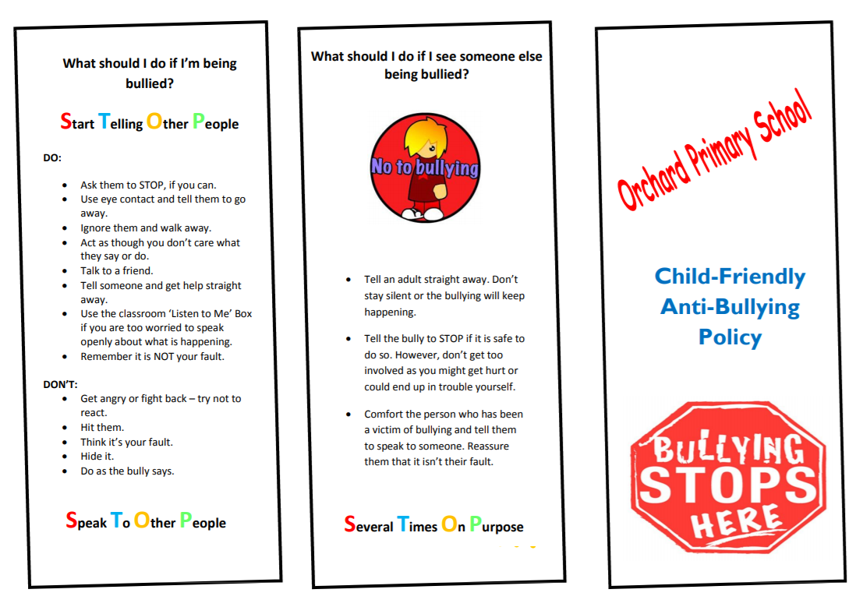
Regular Unfair Deliberate No Excuse

Time to talk box
Regular Unfair Deliberate No Excuse

Regular Unfair Deliberate No Excuse


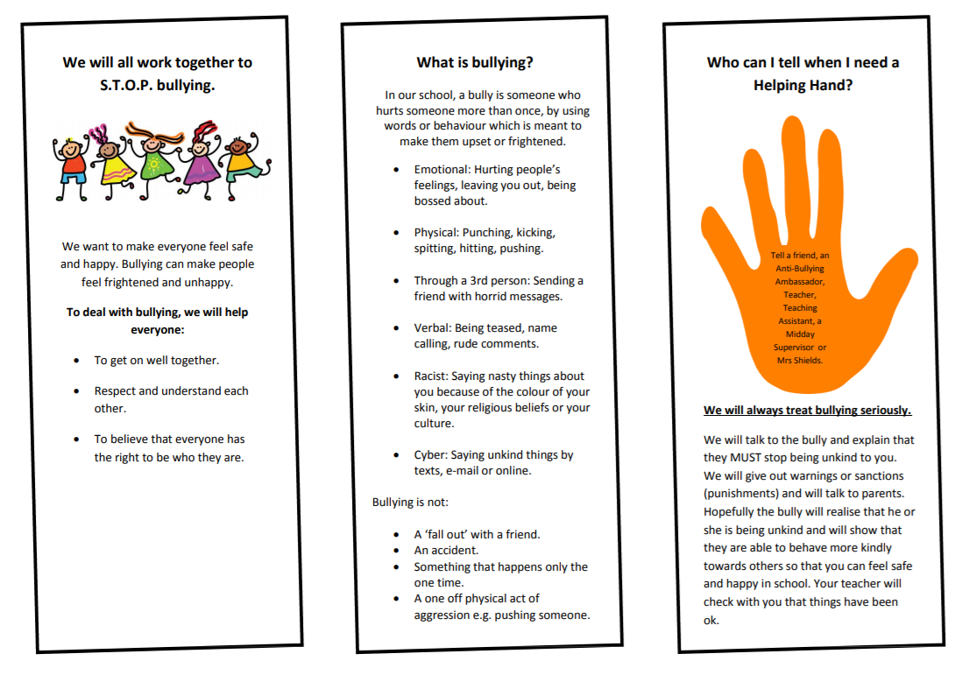
Tell a friend, a member of the school council, a teacher or a teaching assistant, a midday supervisor Learning Mentor
Office Staff Headteacher

We will all work together to STOP bullying.

