School Council have been busy working on their first project.
Mental Health & Wellbeing

Aim: Is for children to feel happy, comfortable, healthy & confidant individuals.

Five ways to wellbeing:

- Keep active.
- Take notice.
- Connect.
- Keep learning.
- Give

School Council met with Rebbeca Bowles (PCSO) who is Spring Bank Primary schools, Wellbeing Champion. During the meeting discussed & outlined a clear plan to delivery workshops, assemblies & lunchtime clubs to promote wellbeing activities.

2nd October whole school assembly to introduce Wellbeing Champion
26th October Rebecca Bowles to help at lunchtime & share key messages to stay healthy (music & dance workshop School Council)

During Autumn 1 whole school to complete Individual Self Care Plans during PSHE lesson & to use them to promote healthy lifestyle.

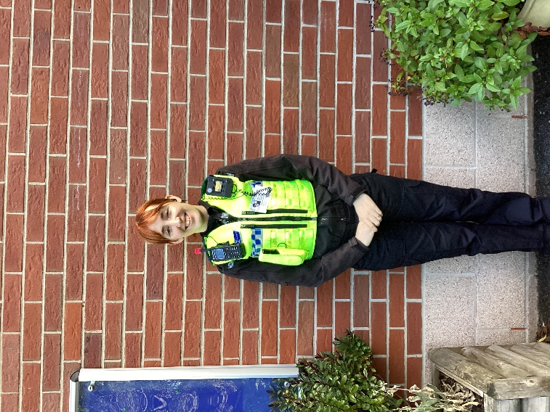
Rebecca Bowles
Spring Bank Primary School Wellbeing Champion

