Spring Bank Primary School Takes Part in Anti Bullying Week
Monday 11th to Friday 15th November 2024

Monday 11th November
Children took part in graffiti Art, with the main focus around what does RESPECT mean to you & what RESPECT looks like.
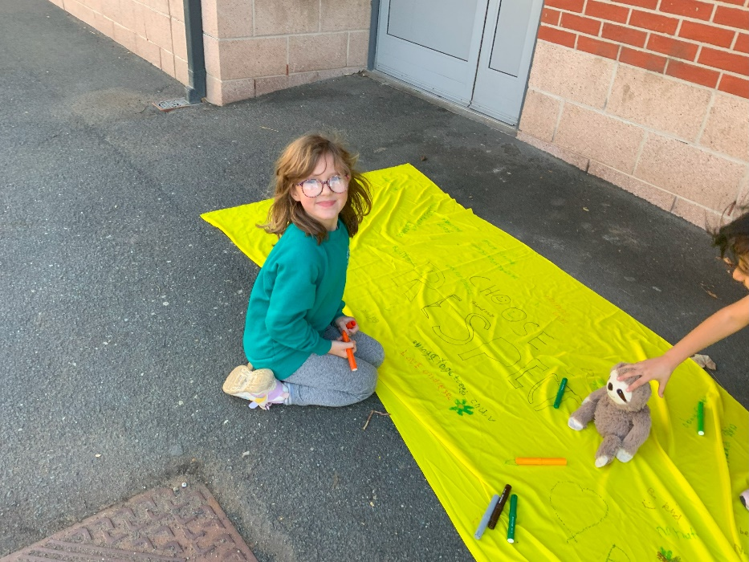

Tuesday 12th November children had the opportunity to come to school in odds socks.
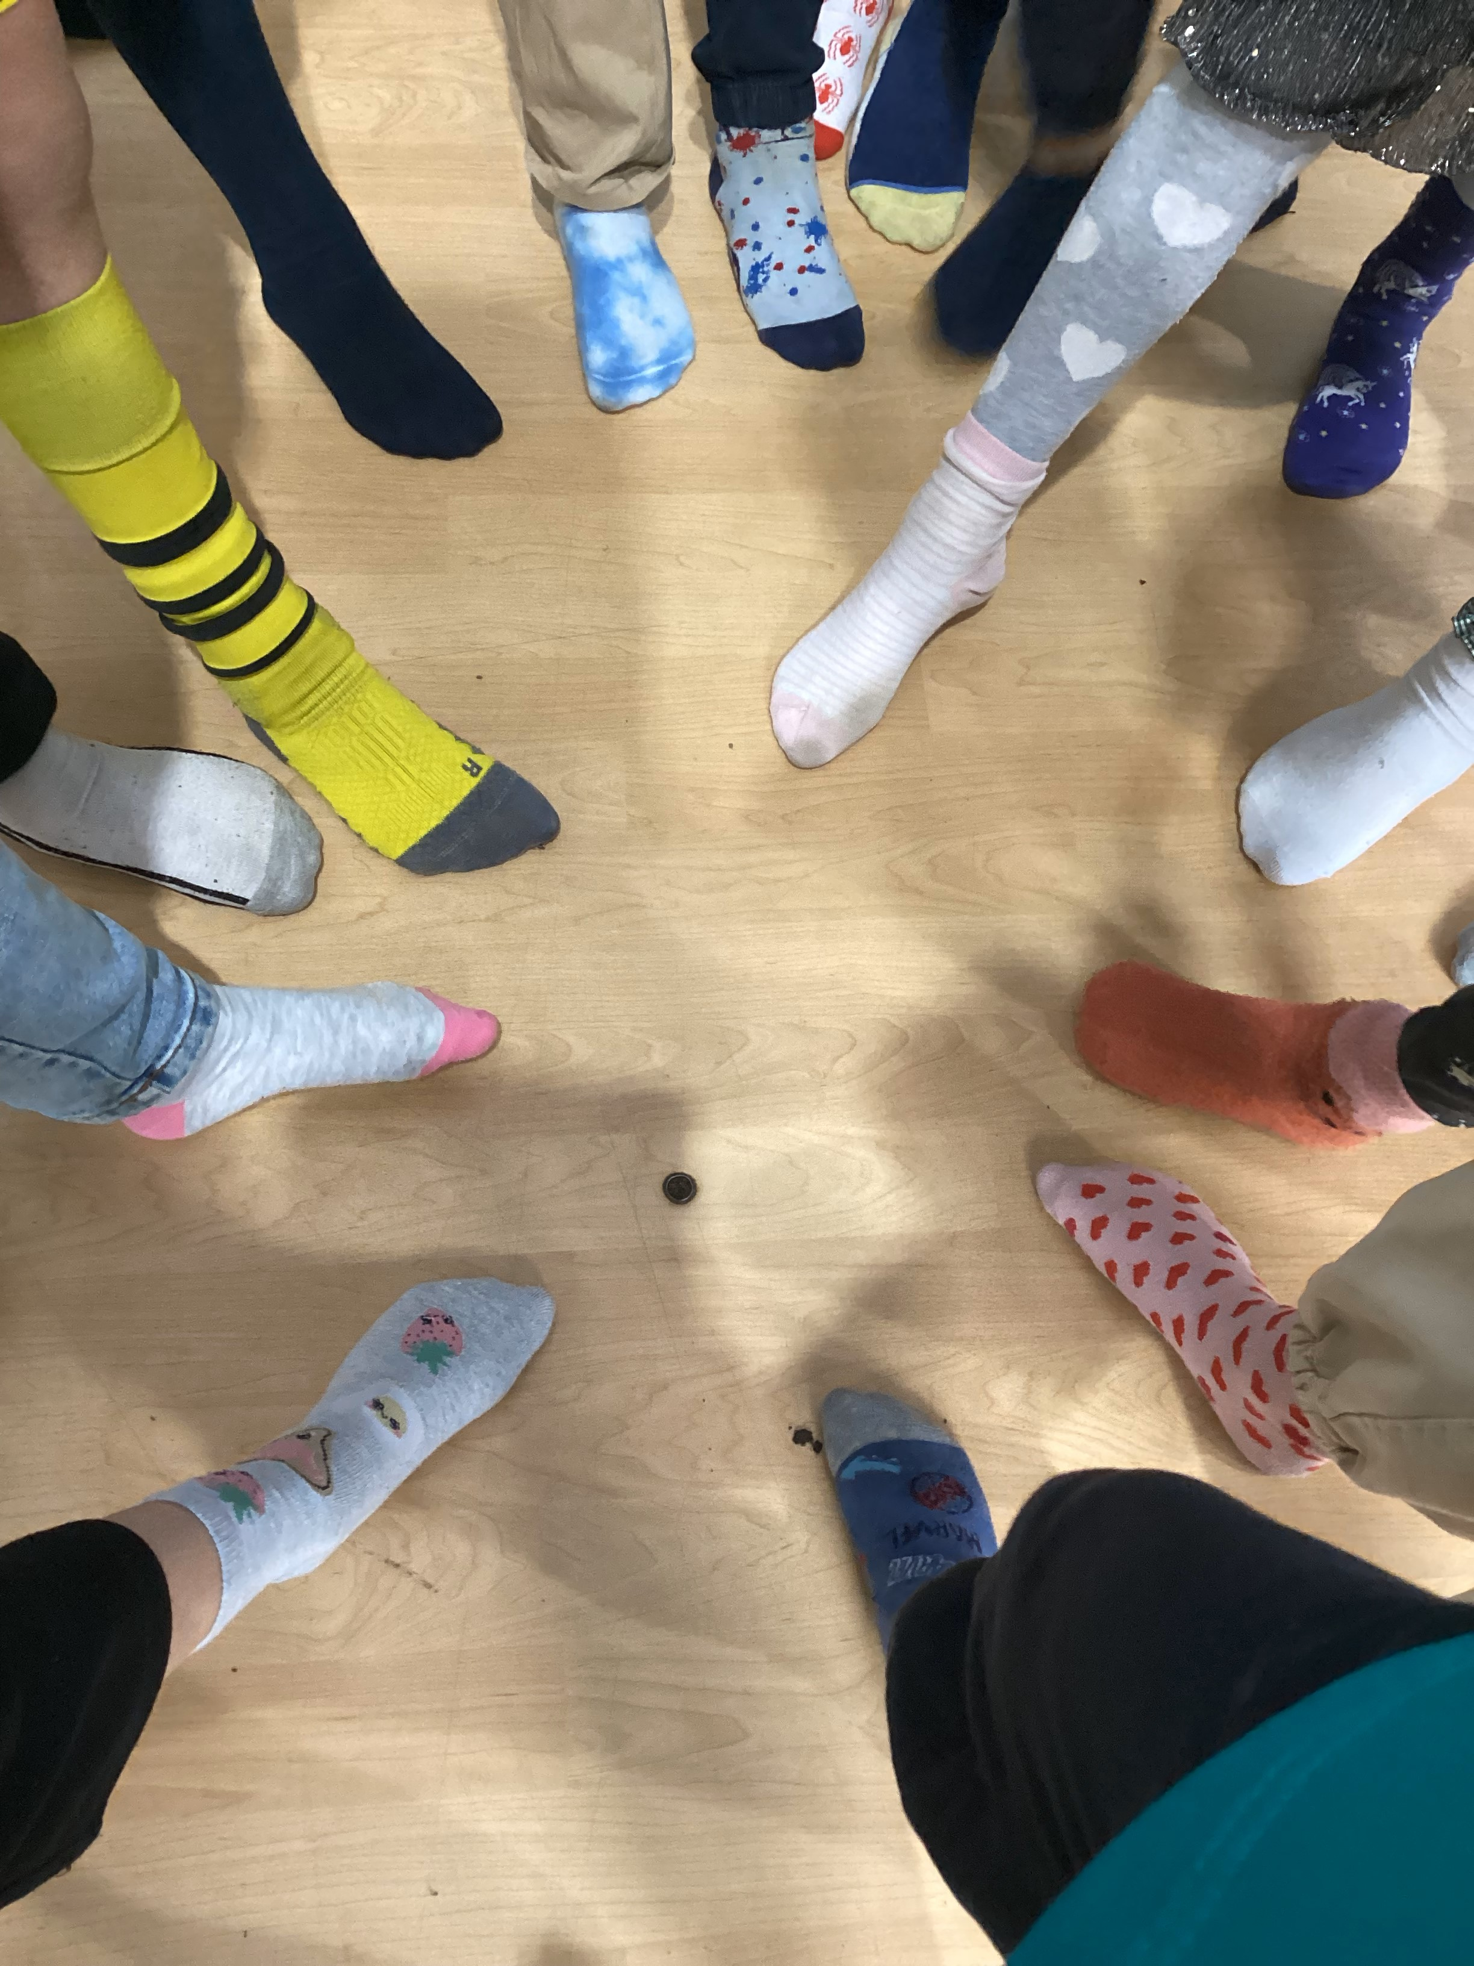
Wednesday 13th November Whole school assembly lead by School Council
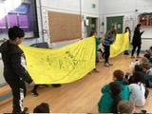

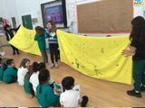

Thursday 14th November during lunchtime children paticpated in dance & drama workshop with key messages around respect & friendships.
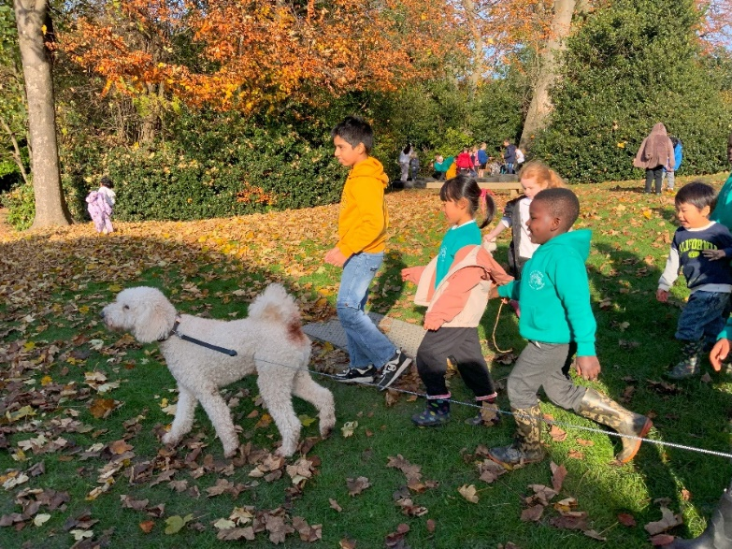

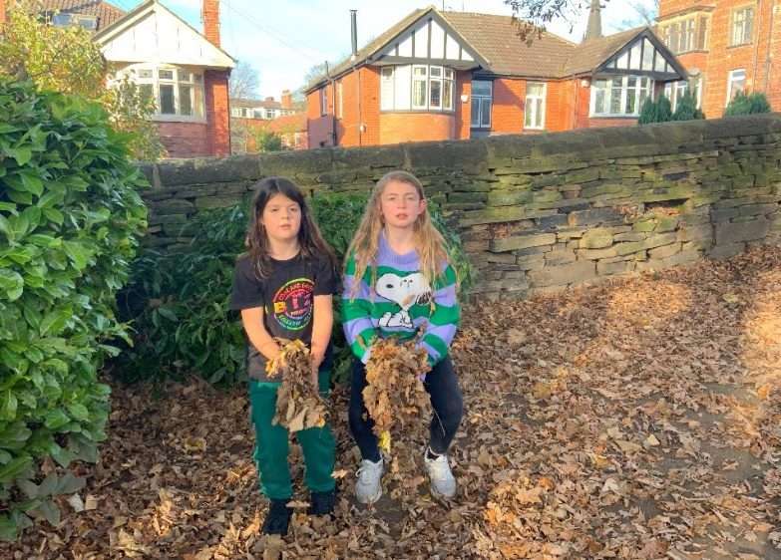
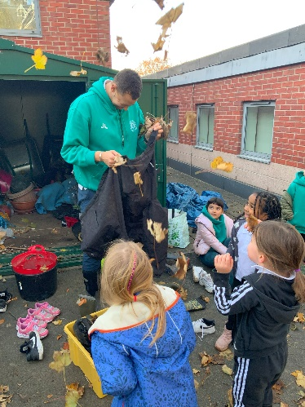

Friday 15th November to mark the end of Anti Bullying Week & to raise money for Children in Need. Whole school including staff came dressed in spots


